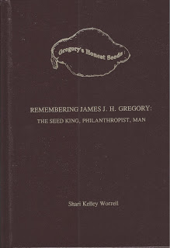

REMEMBERING JAMES J. H. GREGORY:
THE SEED KING, PHILANTHROPIST, MAN

James John Howard Gregory (1827-1910) was born in Marblehead, Massachusetts, the son of James and Hannah (Hooper) Gregory. He always had a love of botany. At the age of four he had his first garden. His main responsibility was to keep it clear of weeds.

JJH was educated in Marblehead schools. He attended Middlebury College but graduated from Amherst College in 1850. He began his work-life as an educator, first as a teacher and then as a principal/headmaster but this was very short-lived.

Answering an ad in the New England Farmer for a nice winter squash, JJH sent the author of the article some seeds from a squash that he had found to his liking. His father called it Marm Hubbard’s Squash because a lady named Hubbard had given him the seeds. The gentleman liked the squash so much that he wrote an article about their desirability. Almost immediately JJH started receiving orders from all over the world for the seeds. Thus began the accidental start of the James J. H. Gregory Seed Company.

The company grew so much JJH made the decision to quit teaching and devote his time to the seed business. As he started to develop great wealth he made the decision to live on three hundred dollars a year and give away the rest to those less fortunate than he. He lived a very Christian life and lived by the scripture from Galatians 2:10; “All they asked was that we should continue to remember the poor, the very thing I was eager to do.”

Unable to have children he adopted four. He married three times. His philanthropy started in his beloved town of Marblehead but soon extended to schools, missions, educators and pastors. Before too long his heart was touched by southern blacks, white Appalachian mountain schools, India and beyond. He did much for many and did it all without notoriety. He felt all people were created equally so he helped those he thought were being treated unfairly just because it was the right thing to do. He started Marblehead Libraries which overall donated 30,000 books to 120 schools.

This 592 page hardcover book ($43 inc S&H) contains information on his wives, children, grandchildren, ancestry and descendants. It includes many of his lectures that still pertain in today’s times. Learn about his extensive philanthropy and extending hand!

After reading about this kind and generous man you, too, will realize that James John Howard Gregory was a man who should not be forgotten!

A thumbnail sketch can be found at: http://www.saveseeds.org/biography/gregory/

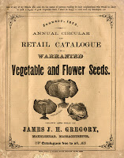

Here's something JJH wrote:

JJH WRITES OF FAMILY, GOD, MANKIND
James J. H. Gregory at Seventy-Eight.

In my seventy-eighth year I sit down to send my annual greetings to the many thousands of friends with whom I have enjoyed many seasons of pleasant intercourse; with some of you well nigh to fifty years. I trust that this finds you enjoying the blessings of good health and prosperity, not only in worldly affairs but in everything where attainment fits us to a higher manhood and nobler womanhood. I am happy to be able to say that I am in the enjoyment of many blessings, physical, mental and moral, for which I daily thank that dear father and mother (long since departed this earth) who gave them to me as a heritage, and the great loving Father of us all through whose laws they were enabled to transmit blessings to their many children. Not having been blessed with a family of my own, I adopted at one time in early marriage life four little children, strangers to me and strangers to each other; these I educated (and many other unfortunate ones) and now, in my declining years, I enjoy the pleasure of being called “Grandpa” by seventeen bright, healthy, little ones.
J. J. H. Gregory
Information found in The American Florist, Vol. 24, 4 Feb 1905

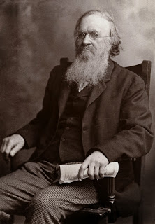

…and a poem he wrote to his daughter:

I WILL BE RICH IN ANOTHER COUNTRY

Why should I agonize below
To pile success in dollars high
Struggling with my fellow man
To get of him the mastery?

In the fierce fight for worldly wealth
My spirit nature dwarfs and starves,
If I but gain what others lose
My riches are but spoils of war.

The earthly harvest for such work
Will cost the immortal soul too dear
Withdrawing from such worldly strife
I will be rich, but not rich here.

God help me pile in that good bank
Whose sacred vaults beyond the stars
The angels tend with willing feet
Riches that are not the spoils of war.

The gold of mercy, gems afire
That from the human heart are mixed
Which he who yearns towards fellow men
In spirit depth can always find.

Then when I reach the heavenly shores
I there shall find my title clear,
Endorsed by Calvary’s dying love,
To riches rare which heaven holds dear.

JJHG

Poem sent to Mrs. Simeon Coffin
(Laura Harwood Gregory)
10 August 1899

Seed Savers had the following to say about the book:
Hi, Shari.
What an amazing book you have put together! With the dozens of photos, illustrations and reproductions of JJH's manuscripts and published pieces by and about him, and the exhaustive information on family and on varieties he introduced, this is an invaluable biographical volume for our library. Thank you for all the work you did to make it, and for inviting our assistance with the documentation of varieties Gregory introduced. We are very pleased to have had even a modest role in the creation of this book!
Bill Musser, Librarian
Seed Savers Exchange
3094 North Winn Road
Decorah, IA 52101
563-387-5622
fax: 563-382-5872

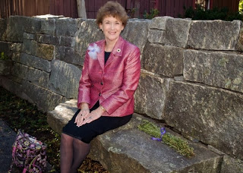

About the author:

Sharyn “Shari” Dianne KELLEY was a Stewardess (Flight Attendant) for United Airlines for over 35 years. She took early retirement in Jun 2002 due to a work-related injury.

Shari has been very active in volunteer work throughout her life (starting at age 8 with U.N.I.C.E.F.); Muscular Dystrophy Association (co-founded Young Women's League for MDA); Centinela Valley Community and Good Sheperd Hospitals (served as volunteer and as President of the Auxiliary); Boy Scouts of America; National Lutheran Association of Scouters; Trinity Methodist Church; Immanuel Lutheran Church and School, etc. She is a member of over 60 hereditary societies (serving on committees and as an officer on local, state and national levels). Shari founded the Order of the First Families of New Hampshire 1622-1680 and served as the presiding officer of OFFNH, Associated Daughters of Early American Witches and The National Guild of St. Margaret of Scotland (Reorganizing President General).

Shari was awarded the Presidential Service Award by George W. Bush and is listed in Who’s Who in America, Who’s Who in the World and Who’s Who Among American Women.

Shari lobbied for many years for exoneration of her 9x great grandmother, Susanna (North) Martin who was executed as a "witch" on 19 Jul 1692 during the Salem Witch Hysteria. A bill for the exoneration of Susanna and four others (Bridget Bishop, Wilmot Reed, Margaret Scott and Alice Parker) was presented to the Commonwealth of Massachusetts in 1997/1998. For three sessions the bill got stuck in committee and tabled. The bill was signed by Acting Governor, Jane Swift, on 31 Oct. 2001. A memorial church service was held on 9 Jun 2002 in Salem, Essex, MA at which time all 20 who had been persecuted and died from those false accusations were memorialized.

If you are interested in a copy of Shari’s book, please contact her here: sdworrell@aol.com

